Name: Muhammad Abdullah   
Reg: L1F22BSCS0032

**TASK1:**

**UI:**

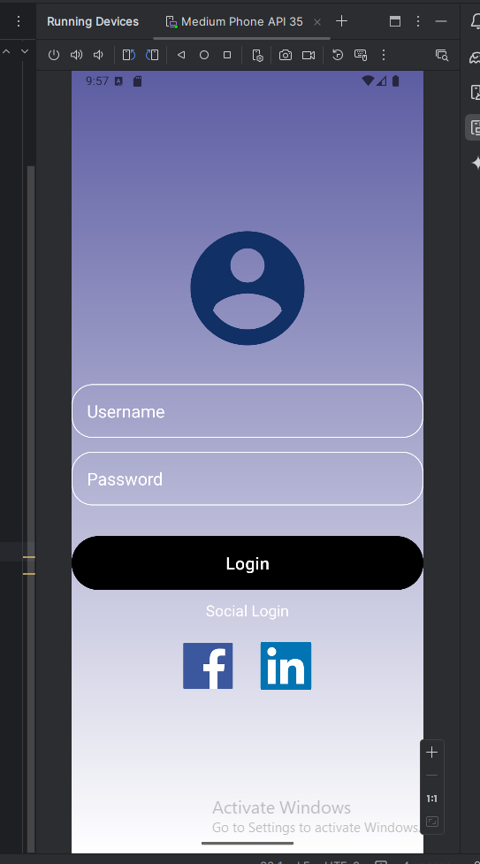

**Code:**

**Acitivitymainxml code:  
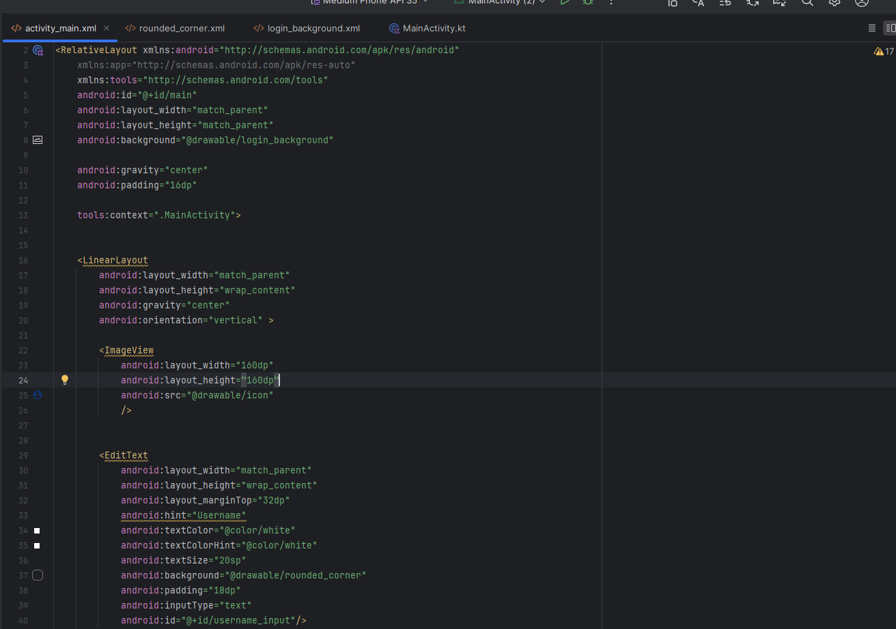**

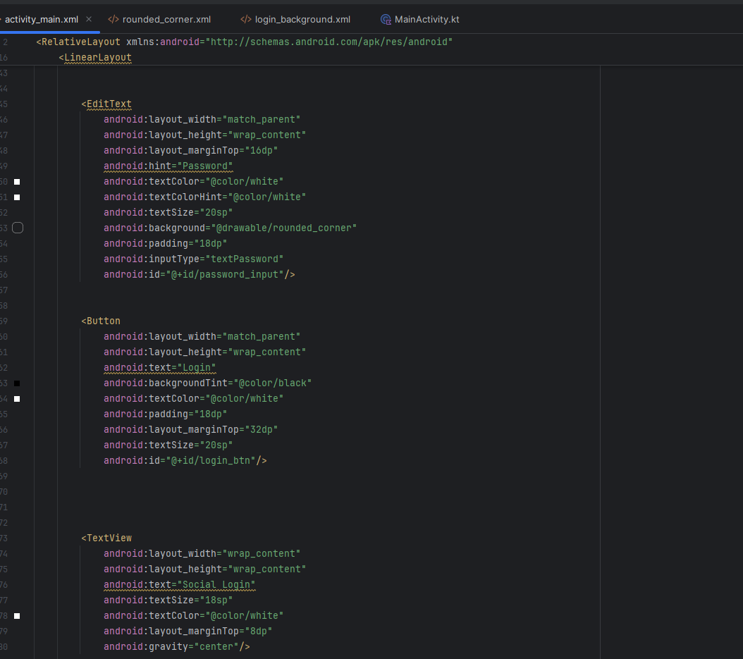

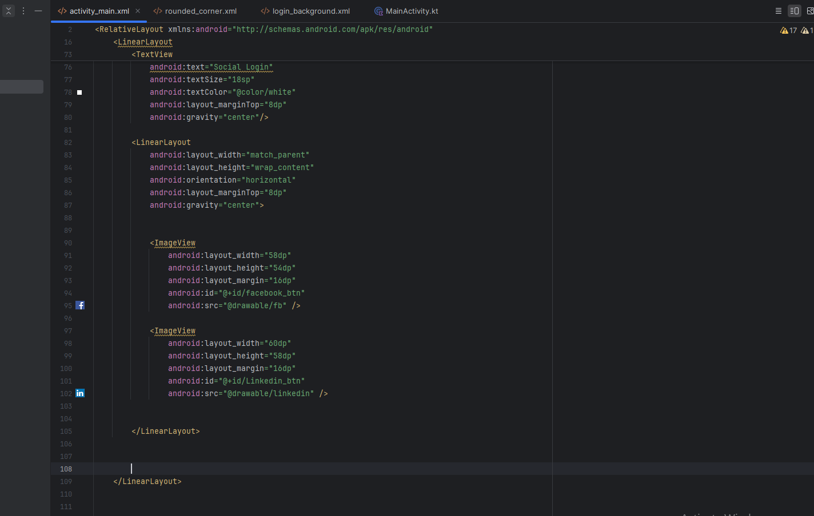

**Rounded corner code xml:**

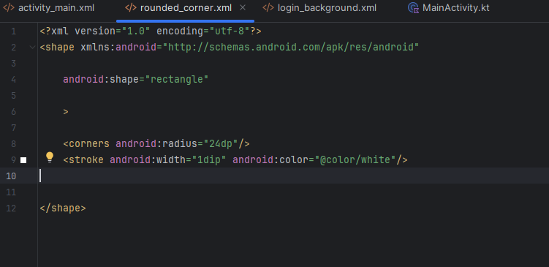

**Login background code xml:**

